Provisioning Report
ASAP 7.0.2 – JAMU66
&
ASAP7.0.2 – WASS1133

Month: August

September 03rd, 2018
Content

1. Summary Transaction Information from JAMU66 3
2. Summary Transaction Information from WASS1133 6
3. Tickets 9
4. Platforms refusing connectivity 12
5. RFC support 14

Summary Transaction Information from JAMU66

JAMU66
Transactions |  | 274,332 | 100%
Start Date |  | 01-August-2018 00:00:00 AM
End Date |  | 31-August-2018 23:59:59 PM
Order Status | Description | Values
COMPLETED | The order was completed with successful response from the Network Element | 244,135 | 89.27%
FAILED | The order was completed with error response from the Network Element | 26,412 | 8.86%
IN_PROG | Orders in Progress | 2 | 0.00%
TIMEOUT | Orders that exceeded the execution time | 3,783 | 1.87%
TRANSL_FAIL | Orders that were not executed | 0 | 0.00%

Day | Total | Transactions  Complete | %  Complete | Transactions  Failed | %  Failed | Transactions  In_Prog | %  In_Prog | Transactions  Timeout | %  Timeout | Transactions  Trans Fail | %  Trans Fail
01/08/2018 | 3,248 | 2,907 | 89.50% | 111 | 3.42% | 1 | 0.03% | 229 | 7.05% | 0 | 0.00%
02/08/2018 | 15,219 | 12,728 | 83.63% | 1,112 | 7.31% | 0 | 0.00% | 1,379 | 9.06% | 0 | 0.00%
03/08/2018 | 15,548 | 14,170 | 91.14% | 1,143 | 7.35% | 0 | 0.00% | 235 | 1.51% | 0 | 0.00%
04/08/2018 | 6,281 | 5,552 | 88.39% | 512 | 8.15% | 0 | 0.00% | 217 | 3.45% | 0 | 0.00%
05/08/2018 | 2,553 | 2,234 | 87.50% | 38 | 1.49% | 0 | 0.00% | 281 | 11.01% | 0 | 0.00%
06/08/2018 | 2,661 | 2,357 | 88.58% | 85 | 3.19% | 0 | 0.00% | 219 | 8.23% | 0 | 0.00%
07/08/2018 | 17,841 | 17,087 | 95.77% | 654 | 3.67% | 0 | 0.00% | 100 | 0.56% | 0 | 0.00%
08/08/2018 | 12,515 | 11,976 | 95.69% | 492 | 3.93% | 0 | 0.00% | 47 | 0.38% | 0 | 0.00%
09/08/2018 | 10,570 | 10,040 | 94.99% | 485 | 4.59% | 0 | 0.00% | 45 | 0.43% | 0 | 0.00%
10/08/2018 | 8,441 | 7,872 | 93.26% | 524 | 6.21% | 0 | 0.00% | 45 | 0.53% | 0 | 0.00%
11/08/2018 | 4,142 | 3,871 | 93.46% | 228 | 5.50% | 0 | 0.00% | 43 | 1.04% | 0 | 0.00%
12/08/2018 | 1,860 | 1,800 | 96.77% | 17 | 0.91% | 0 | 0.00% | 43 | 2.31% | 0 | 0.00%
13/08/2018 | 8,350 | 7,781 | 93.19% | 526 | 6.30% | 0 | 0.00% | 43 | 0.51% | 0 | 0.00%
14/08/2018 | 11,435 | 10,889 | 95.23% | 503 | 4.40% | 0 | 0.00% | 43 | 0.38% | 0 | 0.00%
15/08/2018 | 14,747 | 13,769 | 93.37% | 930 | 6.31% | 0 | 0.00% | 48 | 0.33% | 0 | 0.00%
16/08/2018 | 11,675 | 11,194 | 95.88% | 432 | 3.70% | 0 | 0.00% | 49 | 0.42% | 0 | 0.00%
17/08/2018 | 6,785 | 6,331 | 93.31% | 405 | 5.97% | 0 | 0.00% | 49 | 0.72% | 0 | 0.00%
18/08/2018 | 3,774 | 3,608 | 95.60% | 123 | 3.26% | 0 | 0.00% | 43 | 1.14% | 0 | 0.00%
19/08/2018 | 2,086 | 1,998 | 95.78% | 45 | 2.16% | 0 | 0.00% | 43 | 2.06% | 0 | 0.00%
20/08/2018 | 8,943 | 8,447 | 94.45% | 451 | 5.04% | 0 | 0.00% | 45 | 0.50% | 0 | 0.00%
21/08/2018 | 8,420 | 7,910 | 93.94% | 466 | 5.53% | 0 | 0.00% | 44 | 0.52% | 0 | 0.00%
22/08/2018 | 10,656 | 9,962 | 93.49% | 651 | 6.11% | 0 | 0.00% | 43 | 0.40% | 0 | 0.00%
23/08/2018 | 8,954 | 7,320 | 81.75% | 1,586 | 17.71% | 0 | 0.00% | 48 | 0.54% | 0 | 0.00%
24/08/2018 | 9,321 | 6,847 | 73.46% | 2,430 | 26.07% | 0 | 0.00% | 44 | 0.47% | 0 | 0.00%
25/08/2018 | 4,901 | 3,683 | 75.15% | 1,181 | 24.10% | 0 | 0.00% | 37 | 0.75% | 0 | 0.00%
26/08/2018 | 2,147 | 1,918 | 89.33% | 207 | 9.64% | 0 | 0.00% | 22 | 1.02% | 0 | 0.00%
27/08/2018 | 13,016 | 10,535 | 80.94% | 2,408 | 18.50% | 0 | 0.00% | 73 | 0.56% | 0 | 0.00%
28/08/2018 | 14,275 | 11,952 | 83.73% | 2,278 | 15.96% | 0 | 0.00% | 45 | 0.32% | 0 | 0.00%
29/08/2018 | 10,191 | 7,782 | 76.36% | 2,362 | 23.18% | 1 | 0.01% | 46 | 0.45% | 0 | 0.00%
30/08/2018 | 14,040 | 11,972 | 85.27% | 2,003 | 14.27% | 0 | 0.00% | 65 | 0.46% | 0 | 0.00%
31/08/2018 | 9,737 | 7,643 | 78.49% | 2,024 | 20.79% | 0 | 0.00% | 70 | 0.72% | 0 | 0.00%
SUMMARY  AVERAGE | 274,332 | 244,135 | 89.27% | 26,412 | 8.86% | 2 | 0.00% | 3,783 | 1.87% | 0 | 0.00%

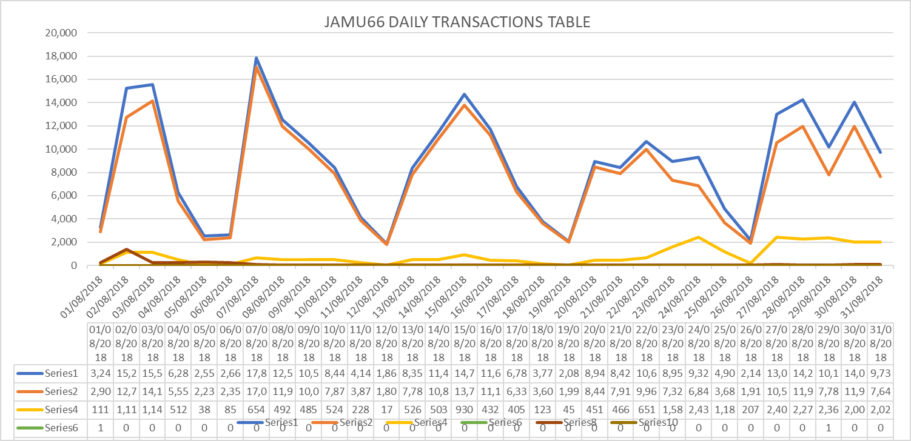

Summary Transaction Information from WASS1133

WASS1133 |  |  | %
Transactions |  | 97,290 | 100%
Start Date |  | 31-August-2018 00:00:00 AM
End Date |  | 31-August-2018 23:59:59 PM
Order Status | Description | Values
COMPLETED | The order was completed with successful response from the Network Element | 70,643 | 72.20%
FAILED | The order was completed with error response from the Network Element | 21,281 | 20.47%
IN_PROG | Orders in Progress | 1 | 0.00%
TIMEOUT | Orders that exceeded the execution time | 5,365 | 1.37%
TRANSL_FAIL | Orders that were not executed | 0 | 0.00%

Day | Total | Transactions  Complete | %  Complete | Transactions  Failed | %  Failed | Transactions  In_Prog | %  In_Prog | Transactions  Timeout | %  Timeout | Transactions  Trans Fail | %  Trans Fail
01/08/2018 | 447 | 367 | 82.10% | 80 | 17.90% | 0 | 0.00% | 0 | 0.00% | 0 | 0.00%
02/08/2018 | 750 | 552 | 73.60% | 181 | 24.13% | 0 | 0.00% | 17 | 2.27% | 0 | 0.00%
03/08/2018 | 432 | 342 | 79.17% | 85 | 19.68% | 0 | 0.00% | 5 | 1.16% | 0 | 0.00%
04/08/2018 | 139 | 112 | 80.58% | 22 | 15.83% | 0 | 0.00% | 5 | 3.60% | 0 | 0.00%
05/08/2018 | 5 | 5 | 100.00% | 0 | 0.00% | 0 | 0.00% | 0 | 0.00% | 0 | 0.00%
06/08/2018 | 225 | 195 | 86.67% | 23 | 10.22% | 0 | 0.00% | 7 | 3.11% | 0 | 0.00%
07/08/2018 | 8,055 | 7234 | 89.81% | 684 | 8.49% | 1 | 0.01% | 136 | 1.69% | 0 | 0.00%
08/08/2018 | 5,142 | 3399 | 66.10% | 1557 | 30.28% | 0 | 0.00% | 186 | 3.62% | 0 | 0.00%
09/08/2018 | 3,250 | 1707 | 52.52% | 1351 | 41.57% | 0 | 0.00% | 192 | 5.91% | 0 | 0.00%
10/08/2018 | 2,952 | 1371 | 46.44% | 1372 | 46.48% | 0 | 0.00% | 209 | 7.08% | 0 | 0.00%
11/08/2018 | 1,600 | 468 | 29.25% | 945 | 59.06% | 0 | 0.00% | 187 | 11.69% | 0 | 0.00%
12/08/2018 | 383 | 38 | 9.92% | 168 | 43.86% | 0 | 0.00% | 177 | 46.21% | 0 | 0.00%
13/08/2018 | 4,329 | 2530 | 58.44% | 1603 | 37.03% | 0 | 0.00% | 196 | 4.53% | 0 | 0.00%
14/08/2018 | 3,937 | 2115 | 53.72% | 1621 | 41.17% | 0 | 0.00% | 201 | 5.11% | 0 | 0.00%
15/08/2018 | 4,204 | 3007 | 71.53% | 1001 | 23.81% | 0 | 0.00% | 196 | 4.66% | 0 | 0.00%
16/08/2018 | 3,825 | 3096 | 35.20% | 534 | 6.26% | 0 | 0.00% | 195 | 58.54% | 0 | 0.00%
17/08/2018 | 2,212 | 1645 | 83.81% | 368 | 14.94% | 0 | 0.00% | 199 | 1.25% | 0 | 0.00%
18/08/2018 | 1,173 | 738 | 88.64% | 238 | 10.53% | 0 | 0.00% | 197 | 0.83% | 0 | 0.00%
19/08/2018 | 420 | 181 | 75.75% | 40 | 17.39% | 0 | 0.00% | 199 | 6.85% | 0 | 0.00%
20/08/2018 | 5,475 | 4522 | 87.27% | 746 | 11.42% | 0 | 0.00% | 207 | 1.31% | 0 | 0.00%
21/08/2018 | 4,798 | 3992 | 86.06% | 589 | 13.00% | 0 | 0.00% | 217 | 0.94% | 0 | 0.00%
22/08/2018 | 6,818 | 4971 | 55.89% | 1638 | 14.01% | 0 | 0.00% | 209 | 30.10% | 0 | 0.00%
23/08/2018 | 4,859 | 3846 | 80.51% | 789 | 11.46% | 0 | 0.00% | 224 | 8.03% | 0 | 0.00%
24/08/2018 | 3,627 | 2855 | 87.10% | 552 | 9.72% | 0 | 0.00% | 220 | 3.19% | 0 | 0.00%
25/08/2018 | 1,478 | 1159 | 88.85% | 167 | 9.27% | 0 | 0.00% | 152 | 1.88% | 0 | 0.00%
26/08/2018 | 285 | 133 | 80.58% | 27 | 12.39% | 0 | 0.00% | 125 | 7.02% | 0 | 0.00%
27/08/2018 | 7,202 | 5933 | 84.26% | 873 | 15.30% | 0 | 0.00% | 396 | 0.44% | 0 | 0.00%
28/08/2018 | 6,123 | 4561 | 83.05% | 1298 | 16.28% | 0 | 0.00% | 264 | 0.68% | 0 | 0.00%
29/08/2018 | 4,330 | 3113 | 73.26% | 968 | 22.56% | 0 | 0.00% | 249 | 4.18% | 0 | 0.00%
30/08/2018 | 5,722 | 4139 | 81.94% | 1302 | 17.26% | 0 | 0.00% | 281 | 0.80% | 0 | 0.00%
31/08/2018 | 3,093 | 2317 | 86.06% | 459 | 13.17% | 0 | 0.00% | 317 | 0.77% | 0 | 0.00%
SUMMARY  AVERAGE | 97,290 | 70,643 | 72.20% | 21,281 | 20.47% | 1 | 0.00% | 5,365 | 1.37% | 0 | 0.00%

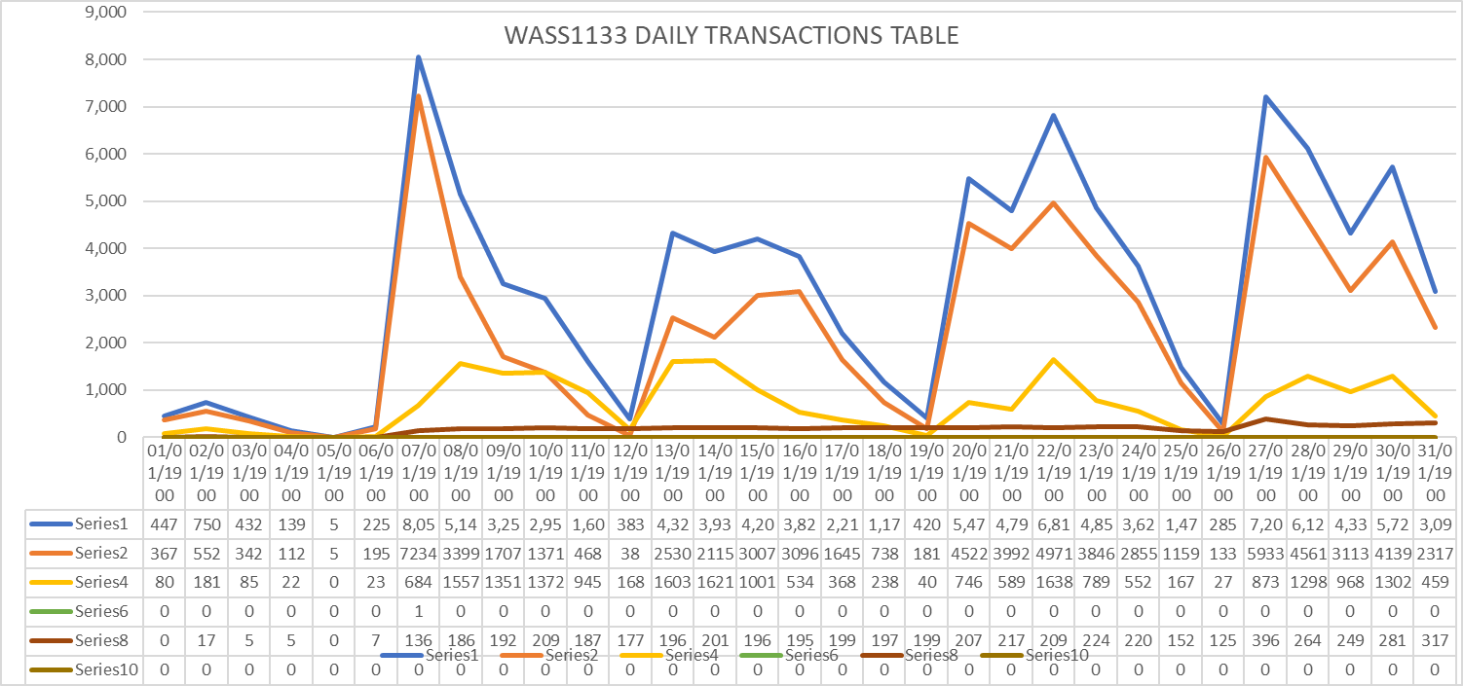

Tickets
June Statistics
Tickets | 28
Severity
LOW | 28
MEDIUM | 0
HIGH | 0
Origin
asap.support | 2
Case Mora | 1
Chinnasani | 2
JaganMohan | 1
Joy | 2
Kenyatta | 1
Kishore | 2
Madhusudan | 3
Neilsa | 2
Prakash | 5
Praneetha | 3
Samantha | 2
Suresh | 1
Terry | 1
Connection Refused | 0

Accumulative
Tickets | 310
Severity
LOW | 204
MEDIUM | 60
HIGH | 46
Origin
Abhijit | 1
asap.support | 16
Barbara | 2
Case Mora | 1
Chinnasani | 7
Chinnasani Prasanna | 1
FLOW IT AUTOMATED PROVISIONING | 1
Harish, Prakash | 2
IGATE LIBERATE TIER 2 SUPPORT | 1
JaganMohan | 1
Jason | 1
Joy | 18
Juan Pablo | 4
Kenyatta | 1
Kishore | 14
Kishore, Shalana | 1
León | 1
Madhusudan | 3
Madhusudhan Adapala | 4
Marcia | 1
Mark | 2
Mora | 1
Mounika | 12
Neilsa | 103
Neilsa, Chinnasani | 1
Neilsa, Kishore | 1
Nola | 2
Prackash | 19
Pradeep | 1
Praneetha | 16
Rhonda | 2
Rosaline | 1
Samantha | 7
Shalana | 3
Shivanchyut | 1
Shivanchyut Baghel | 1
Suresh | 8
Terry | 2
Uday | 2
Wendy | 1
Connection Refused | 43

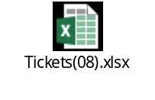

Platforms refusing connectivity

CONNECTION REFUSE E-MAIL TITLE | DATE | STATUS
ASAP monitor; connection refused SLU_UVF | 24/1/18 | CLOSED
ASAP monitor; connection refused EST_GSAT & EST_GSAT1 | 25/1/18 | OPEN
ASAP monitor; connection refused SLU_UVF | 30/1/18 | CLOSED
ASAP monitor; connection refused SLU_UVF | 2/2/18 | CLOSED
ASAP monitor; connection refused SLU_UVF | 5/2/18 | CLOSED
ASAP monitor; connection refused SLU_UVF | 6/2/18 | CLOSED
ASAP monitor; connection refused SLU_CEN | 5/2/18 | CLOSED
ASAP monitor; connection refused SLU_UVF | 9/2/18 | CLOSED
ASAP monitor; connection refused JAM_CALIX | 13/2/18 | OPEN
ASAP monitor; connection refused SLU_UVF | 16/2/18 | CLOSED
ASAP-WASS133-ASAP There is no connection to Database -No Listener | 18/2/18 | CLOSED
ASAP JAMU66 shutdown | 22/2/18 | CLOSED
ASAP monitor; connection refused SLU_UVF | 22/2/18 | CLOSED
ASAP monitor; connection refused CAY_GNBND with WASS1133 | 22/2/18 | OPEN
ASAP monitor; connection refused SLU_UVF | 22/2/18 | CLOSED
ASAP monitor; connection refused SLU_UVF | 28/2/18 | CLOSED
WASS1133-ASAP provisioning asappro1 user fails to login | 28/2/18 | CLOSED
ASAP monitor; connection refused SLU_CEN | 5/3/18 | CLOSED
JAM_MOBY connection failure | 9/3/18 | CLOSED
ASAP-FLOW-monitor, Unable to connect to remote host: Connection refused to SLU_UVF | 13/3/18 | CLOSED
ASAP monitor; connection refused SLU_UVF | 14/3/18 | CLOSED
ASAP monitor; connection refused SLU_UVF | 28/3/18 | CLOSED
ASAP monitor; connection refused SLU_UVF | 2/4/18 | CLOSED
ASAP monitor; connection refused SLU_UVF | 3/4/18 | CLOSED
ASAP monitor; connection refused JAM_EAST | 3/4/18 | CLOSED
ASAP monitor; connection refused SLU_UVF | 5/4/18 | CLOSED
ASAP monitor; connection refused SLU_UVF | 9/4/18 | CLOSED
ASAP connection refused SONUS | 11/4/18 | CLOSED
ASAP connection refused SONUS | 16/4/18 | CLOSED
ASAP monitor; connection refused SLU_UVF | 16/4/18 | CLOSED
ASAP monitor; connection refused SLU_UVF | 26/4/18 | CLOSED
ASAP monitor; connection refused SLU_CEN | 26/4/18 | CLOSED
ASAP monitor; connection refused SLU_UVF | 30/4/18 | OPEN
ASAP monitor; connection refused SLU_UVF | 2/5/18 | CLOSED
LIME-ASAP-jamu66-Connection Fail to SONUS platform | 28/5/18 | CLOSED
ASAP monitor; connection refused SLU_UVF | 11/06/18 | CLOSED
ASAP monitor; connection refused SLU_UVF | 11/06/18 | CLOSED
ASAP monitor; connection refused SLU_UVF and SLU_CEN | 19/06/18 | CLOSED
ASAP monitor; connection refused SLU_UVF and SLU_CEN | 21/06/18 | CLOSED
ASAP-Route Activation traffic to wass1133 | 24/06/18 | CLOSED
ASAP monitor; connection refused SLU_UVF | 03/07/18 | CLOSED
ASAP monitor; connection refused SLU_UVF | 04/07/18 | CLOSED
ASAP monitor; connection refused SLU_UVF | 23/07/18 | CLOSED

RFC support

CONCEPT | DATE
RFC 4080434 - Barbados HLR CP Upgrade from R12B to R15A | 25/01/2018
|RFC6786| SCHEDULED RFC NOTIFICATION Cleandata Routine Maintenance on JAMU66 | 22/02/2018
RFC6955-Reroute provisioning on Barbados HLR to Jamaica HLR - MW3 | 7/03/2018
|RFC7430| SCHEDULED RFC NOTIFICATION Routine Maintenance: ASAP Cleandata on JAMU66 server | 11/04/2018
|RFC8041| SCHEDULED RFC NOTIFICATION ASAP Cleandata Maintenance Activity - JAMU66 | 24/05/2018

